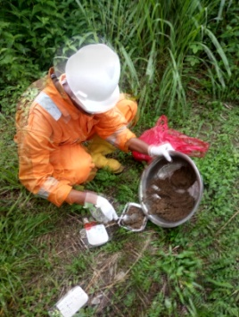
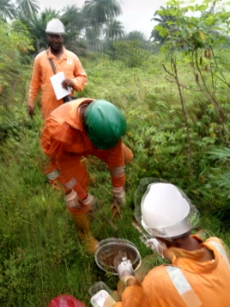

KM 17.5ODHIAJE COMMUNITY, AHOADA EAST

